
Chittagong University of Engineering and Technology
Department of Electrical and Electronic Engineering

Project Title –Temperaturemeasuring circuitusing the LM324 op-amp, thermistor, AVR ATmega328p microcontroller
Course No. - EEE 354
Course Title - Measurement and Instrumentation Sessional
Date –23.10.2017

Submitted to

Mr. Ainul Anam Shahjamal Khan
Associate Professor
Department of Electrical and Electronic Engineering
Chittagong University of Engineering and Technology

Mr. Shamsul Arifin
Assistant Professor
Department of Electrical and Electronic Engineering
Chittagong University of Engineering and Technology

Submitted by
1) Fahmid Mahmud, ID: 1402042
2) Md. Riazul Mowla, ID: 1402050
Group – 24

Content

1. Introduction …………….………………………………………………………………………3

2. Circuit Diagram ……………………………...………………………………………………...4

3. Circuit Operation and Design Procedure......……………...…………………………………...5

4. Procedure of Calibration (with data table) ................……………………………...…………...6

5. Required Program (for microcontroller)........................…………………………………….....7

6. Photo of Bread-board Implementation..………………………………………………………..8

7. Test data with error ...……………………………………………………………......................9

8. Component Description ...………………………………………………….............................10

9. Total Cost………………...……………………………………………………………...…....11

10. Conclusion ………………………………………………………………………………......12

Introduction
Now-a-days, modern life cannot be thought without electricity. Electricity has made our life easier with many modern inventions. Modern Electronics has made lives even better with easy implementation of electronic components in our day to day life.
With social life being much easier, the necessity to make it easier than the present days is also increasing day by day. It has given rise to the need for increasing development in projects for efficient execution of daily activities. Now-a-days, many activities are performed with the help of some easy and effective systems,thanks to modern electronics.
In this project, we are going to design a circuit for measuring the temperature using the LM324 op-amp, thermistor, AVR ATmega328 microcontroller & display the reading on the 16×2 LCD display as temperature. After reading the temperature, LM324 op-amp gives the analog output to the AVR ATmega328 microcontroller.
The analog output from LM324 op-amp is sent to the ADC of the ATmega328 that converts the analog data to the digital by inbuilt ADC (Analog-to-Digital Converter) in it.
This project is very useful for controlling of temperature;it can be used for soldering station to make it automatic temperature controlled & as much at homes as in industrial applications.

Circuit Diagram

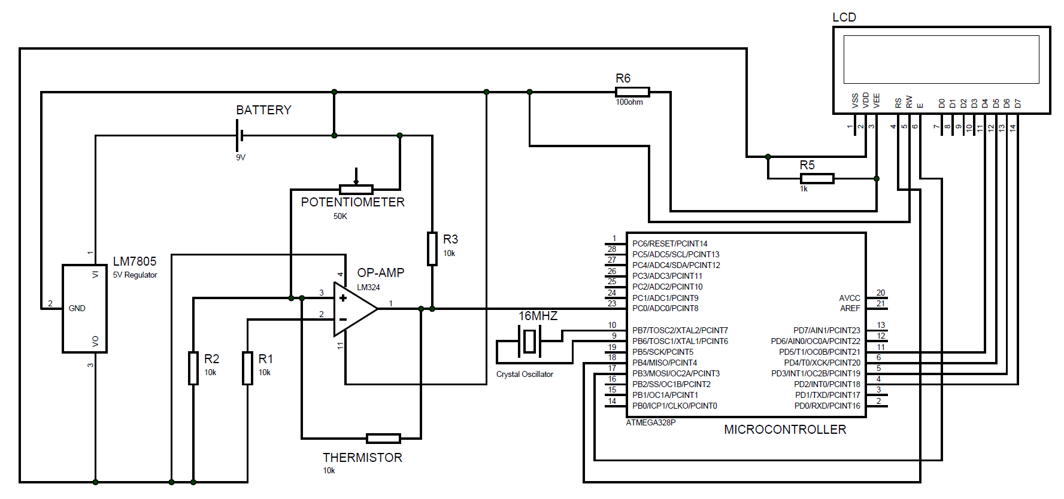

Figure: Circuit Diagram of the projectdrawninPROTEUS.

Circuit Operation & Design Procedure
A basic low-parts-count bridge circuit is used for this project. Resistors R₁ are 1% low Tempco (metal-film) resistors. Current I is constant & set by R₁, R_{ref}& E. That is, I= E/(R₁₊R_{ref}). Note that thermistor current is constant & equal to I because the voltage drops across both R_{1 &}R₂ resistors are equal (E_{d=}0V).
- To select any thermistor on a trial basis. The thermistor converts a temperature change to a resistance change.
- To select the reference temperature. At the reference temperature, V₀ must equal zero. To select either the low limit of 20⁰C or the high limit of 80⁰C. We selected the low limit of 20⁰C for this project. We have just defined R_{ref}. R_{ref} is equal to thermistors resistance at the reference temperature. Specifically, T_{ref}=25⁰C; therefore, R_{ref}=16.6kΩ. Now to calculate ΔR for each temperature.
- To predict the voltage-temperature characteristics,we selected the bridge circuit because it converts a resistance change ΔR into an output voltage.
- To select resistors R₁, R₂to equal 10 kΩ.
- To make a trial for choice for E=5.0V.
- Calculate I from I=E/(R_{ref}+R₁) = 5V/(16.6kΩ+10kΩ) = 0.188mA
- Calculate V₀ for each value of R from equation V₀=IΔR.
- To document performance,Output Voltage, V₀(in volts) is plotted against Temperature (in degrees).

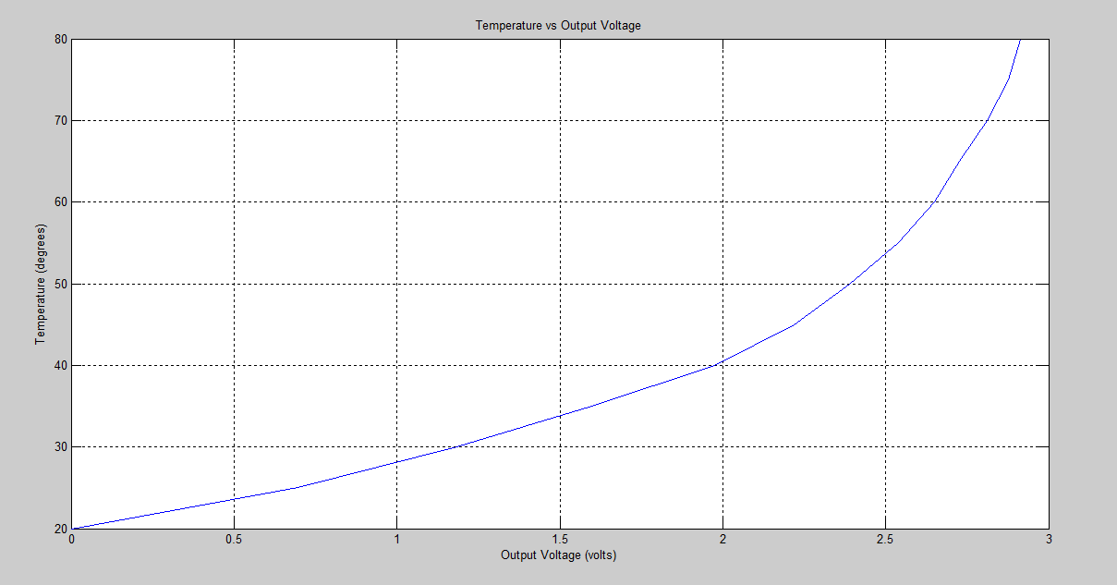
Figure-1: An input temperature change of 20⁰C to 80⁰C gives an output voltage of 0 to 2.914V.
Procedure of Calibration (with data table)
The resistor from (+) input to ground is always chosen to equal the reference resistance of the thermistor. We wanted to V₀ to be zero volts when R₂₀₌R_{ref.} This will allow us to calibrate or check operation of the bridge.
We calculated R_{therm}for different temperatures ranging between 20⁰C to 80⁰C. Then using the plot from Figure-1, we obtained a 5th order equation which is used in the microcontroller program to obtain temperature from voltage.
The equation is: 1.9*(volt)⁵-11*(volt)⁴+23*(volt)³-18*(volt)²+12*volt+20

Calculation for Temperature-to-Voltage Converter is given below:
Temp(⁰C) | R_{therm} (kΩ) | ΔR(Ω) | V₀(volt)
20 | 16.6 | 0 | 0
25 | 12.9 | 3.70 | 0.6956
30 | 10.3 | 6.30 | 1.1844
35 | 8.10 | 8.50 | 1.5980
40 | 6.10 | 10.50 | 1.9740
45 | 4.80 | 11.80 | 2.2184
50 | 3.90 | 12.70 | 2.3876
55 | 3.10 | 13.50 | 2.5380
60 | 2.50 | 14.10 | 2.6508
65 | 2.10 | 14.50 | 2.7260
70 | 1.65 | 14.95 | 2.8106
75 | 1.30 | 15.30 | 2.8764
80 | 1.10 | 15.50 | 2.9140

Required Program (for Microcontroller)
// include the library code:
#include <LiquidCrystal.h>

// initialize the library by associating any needed LCD interface pin
// with the arduino pin number it is connected to
const int rs = 12, en = 11, d4 = 5, d5 = 4, d6 = 3, d7 = 2;
LiquidCrystal lcd(rs, en, d4, d5, d6, d7);

void setup() {
// set up the LCD's number of columns and rows:
lcd.begin(16, 2);
Serial.begin(9600);

}

void loop()
{
float v = analogRead(A0);
Serial.print(v);
Serial.print(" || ");
float volt = (v*5)/(1024);
Serial.print(volt);
Serial.print(" || ");
float temp;
temp= 1.9*volt*volt*volt*volt*volt-11*volt*volt*volt*volt+23*volt*volt*volt-18*volt*volt+12*volt+20;
float t

t= temp;
Serial.println(t);
lcd.setCursor(1,0);
lcd.print("Temperature");
lcd.setCursor(0,1);
lcd.print(t);
lcd.print(" degree C ");
delay(1000);

}

Photo of Bread-board Implementation

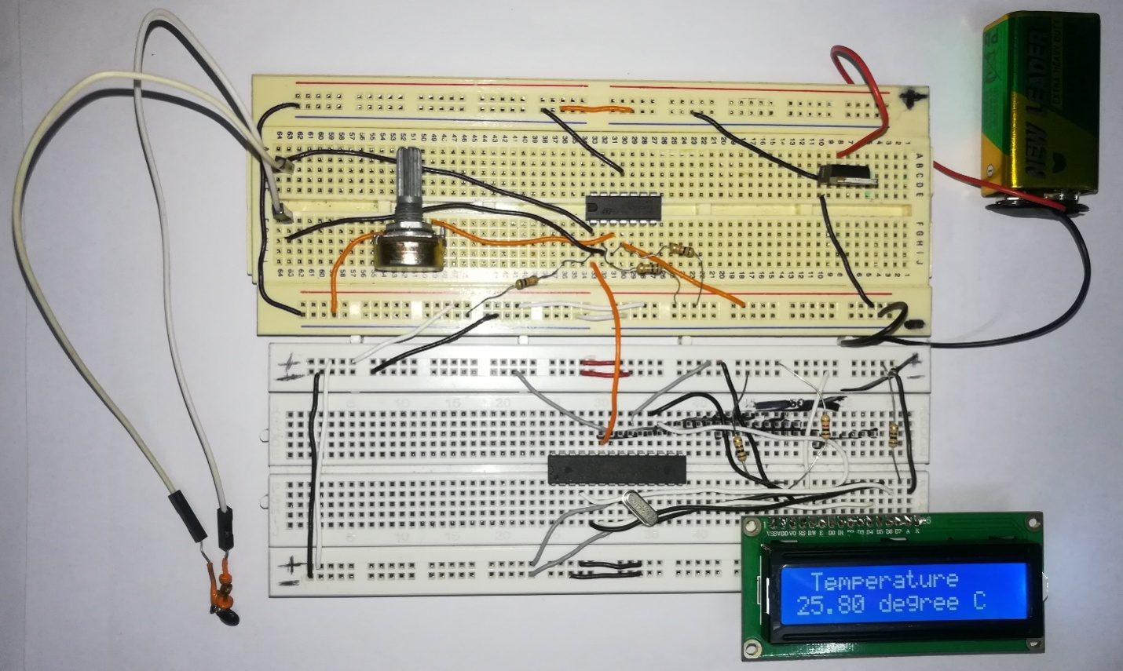
Figure-2: Photo of Bread-board Implementation of the Project.

Test data with error:

No. of obs. | Thermometer reading (°C) | Designed meter reading (°C) | Error (%)
1 | 26 | 26.71 | 2.73
2 | 28 | 27.69 | 1.11
3 | 30 | 29.74 | 0.87
4 | 33 | 33.06 | 0.18
5 | 38 | 37.34 | 1.74
6 | 42 | 41.14 | 2.05
7 | 47 | 45.57 | 3.04
8 | 54 | 52.35 | 3.05
9 | 59 | 58.49 | 0.86
10 | 60 | 60.07 | 0.12
11 | 64 | 63.79 | 0.33
12 | 68 | 68.09 | 0.13
13 | 70 | 73.08 | 4.40
14 | 72 | 75.24 | 4.50
15 | 75 | 79.28 | 5.71

Component Description
LM7805: Voltage regulator IC maintains the output voltage at a constant value. 7805 IC, a voltage regulator integrated circuit (IC) is a member of 78xx series of fixed linear voltage regulator ICs used to maintain such fluctuations. The xx in 78xx indicates the fixed output voltage it provides.

Potentiometer (50kΩ):A potentiometer is a manually, adjustable, variable resistor with three terminals. Two terminals are connected to a resistive element; the third terminal is connected to an adjustable wiper. The position of the wiper determines the output voltage.

Thermistor (10kΩ): A thermistor is a resistance thermometer, or a resistor whose resistance is dependent on temperature. The term is a combination of “thermal” & “resistor”. It is made of metallic oxides, pressed into a bead, disk or cylindrical shape & then encapsulated with an impermeable material such as epoxy or glass.

LM324: LM324 is a 14pin IC consisting of four independent operational amplifiers (op-amps) compensated in a single package. Op-amps are high gain electronic voltage amplifier with differential input and, usually, a single-ended output. They can be used as amplifiers, comparators, oscillators, rectifiers etc.

Crystal Oscillator: A crystal oscillator is an electronic oscillator circuit that uses the mechanical resonance of a vibrating crystal of piezoelectric material to create the electrical signal with a precise frequency. Quartz crystals are manufactured for frequencies from a few tens of kilohertz to hundreds of megahertz.

ATmega328: The ATmega328 is a very popular microcontroller chip produced by Atmel. It is an 8-bit microcontroller that has 32k of flash memory, 1k of EEPROM, and 2k of internal SRAM. ATmega328 has 28 pins. The device operates between 1.8-5.5 volts. It provides a highly flexible & cost effective solution to many embedded control applications.

LCD (16×2): 16×2 LCD unit is widely using in embedded system projects because it is cheap, easily available, small in size & easy to interface. 16×2 have two rows & 16 columns, which means it consist 16 blocks of 5×8 dots. 16 pin for connections in which 8 data bits D0-D7 and 3 control bits namely RS, RW & EN. Rest of pins are used for supply, brightness control & for backlight.
Resistors: We have used three 10 kilo ohm, one 1 kilo ohm& one 100 ohm resistorsin this project.

Battery: One 9V DC battery source is used to power the circuit through the 5V voltage regulator LM7805.

Total Cost

Components Name | Price (Taka)
LM324 | 15
Resistors (5 Pieces) | 5×1=5
ATmega328 | 190
LM7805 | 15
9V DC Battery | 25
Potentiometer (50k) | 35
Connecting Wires | 30
Thermistor | 10
Crystal Oscillator | 15
Battery Cap | 15
LCD | 165
Breadboard (2 Pieces) | 120×2=240
Total Cost | 760

Conclusion
This project is one of the basic projects in the microcontroller based electrical and electronic projects. This is the beginning of many more human-friendly and useful projects involving the amazing features of electrical components which are quite easily available.
From this project, we learnt that how temperature is measured using microcontroller & show the reading on LCD display as well as how a bridge circuit converts the resistance change of a thermistor into a voltage change. The circuit output voltage is linear with respect to ΔR.
However, ΔR is not linear with respect to temperature. Therefore, V₀ is not linear with respect to temperature. The bridge simply transmits the nonlinearity of the thermistor.
The sensitivity of the temperature-to-voltage converter can be increased easily by increasing E. The maximum value of E is set by the maximum thermistor current to avoid self-heating.
Though this project design lacks accuracy in many aspects. Some reasons behind it are,
- The position of thermometer and thermistor while taking the temperature. A slight change in their positions will result in errors between the thermometer reading and LCD display reading.
- The components used, are not exactly accurate according to the theory. This also results in errors.
- It’s quite difficult to maintain the circuit arrangement always as it is supposed to be. Slight movement will result in change in values of the components, resulting in different reading at different samples with the same arrangement.
Beside these contradictions, this project is almost accurate with a little percentage of error. Further improvements like stable arrangements of the components, using precision components etc. will increase the efficiency of this project to a great extent.

